**CODE-CODE GAME INDEX.HTML ,APP.JS, STYLE.CSS**

**1.GAME TIC-TAC-TOE**

* **Index.html**

<!DOCTYPE html>

<html lang="en">

<head>

    <meta charset="UTF-8">

    <meta name="viewport" content="width=device-width, initial-scale=1.0">

    <title>Tic-Tac-Toe</title>

    <link rel="stylesheet" href="style.css"/>

</head>

<body>

    <main>

        <div class="msg-container hide">

            <p id="msg">Winner</p>

            <button id="new-btn">New Game</button>

        </div>

        <div class="container">

            <h1 id="hd">Tic Tac Toe</h1>

            <div class="game">

                <button class="box"></button>

                <button class="box"></button>

                <button class="box"></button>

                <button class="box"></button>

                <button class="box"></button>

                <button class="box"></button>

                <button class="box"></button>

                <button class="box"></button>

                <button class="box"></button>

            </div>

            <button id="reset-btn">Reset Game</button>

        </div>

    </main>

    <script src="app.js"></script>

</body>

</html>

* **APP.JS**

let boxes = document.querySelectorAll(".box");

let resetBtn = document.querySelector("#reset-btn");

let newGameButton = document.querySelector("#new-btn");

let msgContainer = document.querySelector(".msg-container");

let msgContainer2 = document.querySelector(".msg-container2");

let msg = document.querySelector("#msg");

let msg2 = document.querySelector("#msg2");

let container = document.querySelector(".container");

let count = 0;

let turnO = true;

const winPatterns = [

    [0, 1, 2],

    [0, 3, 6],

    [0, 4, 8],

    [3, 4, 5],

    [6, 7, 8],

    [1, 4, 7],

    [2, 5, 8],

    [2, 4, 6]

];

const resetGame = () => {

    turnO = true;

    count=0;

    enableBoxes();

    msgContainer.classList.add("hide");

    container.classList.remove("hide");

}

boxes.forEach((*box*) => {

*box*.addEventListener("click", () => {

        if (count === 9 || checkWinner()) {

            return;

        }

      if (turnO) {

*//playerO*

*box*.innerText = "O";

*box*.style.color="white";

        turnO = false;

      } else {

*//playerX*

*box*.innerText = "X";

*box*.style.color="cyan";

        turnO = true;

      }

*box*.disabled = true;

      count++;

      let isWinner = checkWinner();

      if (count === 9) {

        drawGame();

      }

    });

  });

const disableBoxes = () => {

    for (let box of boxes) {

        box.disabled = true;

    }

}

const enableBoxes = () => {

    for (let box of boxes) {

        box.disabled = false;

        box.innerText = "";

    }

}

const showWinner = (*winner*) => {

    msg.innerText = Congratulations, Winner is ${winner};

    msgContainer.classList.remove("hide");

    container.classList.add("hide");

    if(hideDisplay=="inline"){

        hide2.style.display="none";

    }

    disableBoxes();

}

const drawGame = () => {

    if (!checkWinner()) {

        msg.innerText = "This Game is a Draw.";

        msgContainer.classList.remove("hide");

        container.classList.add("hide");

        disableBoxes();

    }

}

const checkWinner = () => {

    for (let pattern of winPatterns) {

        let pos1Val = boxes[pattern[0]].innerText;

        let pos2Val = boxes[pattern[1]].innerText;

        let pos3Val = boxes[pattern[2]].innerText;

        if (pos1Val != "" && pos2Val != "" && pos3Val != "") {

            if (pos1Val === pos2Val && pos2Val === pos3Val) {

                console.log("winner is ", pos1Val)

                showWinner(pos1Val);

                return true;

            }

        }

    }

    return false;

};

newGameButton.addEventListener("click", resetGame);

resetBtn.addEventListener("click", resetGame);

* **STYLE.CSS**

*{

    margin: 0;

    padding: 0;

}

body{

    background-color: #cbf800;

    text-align: center;

}

#hd{

    margin:30px;

    margin-top:30px;

    color: #fff;

    font-family: system-ui, -apple-system, BlinkMacSystemFont, 'Segoe UI', Roboto, Oxygen, Ubuntu, Cantarell, 'Open Sans', 'Helvetica Neue', sans-serif;

}

.container{

    margin-top:30px;

    height: 70vh;

    display: flex;

    flex-direction: column;

    justify-content: center;

    align-items: center;

}

.game{

    height: 60vmin;

    width: 60vmin;

    display: flex;

    flex-wrap: wrap;

    justify-content: center;

    align-items: center;

    gap:1.5vh;

}

.box{

    height: 18vmin;

    width: 18vmin;

    border-radius: 1rem;

    border: none;

    box-shadow: 0 0 1rem rgba(0, 0, 0, 0.3);

    font-size: 8vmin;

    color: #e0b1cb;

    background-color: #231942;

}

#reset-btn{

    margin: 30px;

    padding: 1rem;

    font-size: 1.25rem;

    background-color: #231942;

    border-radius: 1rem;

    border:none;

    color:#fff;

}

#new-btn{

    padding: 1rem;

    font-size: 1.25rem;

    background-color: #231942;

    border-radius: 1rem;

    border:none;

    color:#fff;

}

#msg{

    color: #fff;

    font-size: 8vh;

    font-family: system-ui, -apple-system, BlinkMacSystemFont, 'Segoe UI', Roboto, Oxygen, Ubuntu, Cantarell, 'Open Sans', 'Helvetica Neue', sans-serif;

}

.msg-container{

    height: 100vmin;

    display: flex;

    justify-content: center;

    align-items: center;

    flex-direction: column;

    gap: 2rem;

}

.hide{

    display: none;

}

.hide2{

    display:inline;

}

GAMBAR :

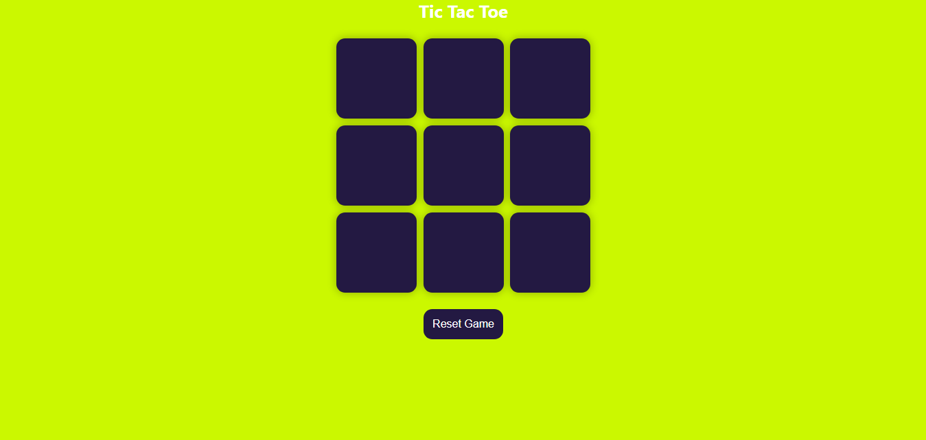

**2. GAME ULAR**

* **INDEX.HTML**

<!DOCTYPE html>

<html lang="en">

<head>

  <meta charset="UTF-8">

  <meta name="viewport" content="width=device-width, initial-scale=1.0">

  <title>Snake Game</title>

  <link rel="stylesheet" href="style.css">

</head>

<body>

  <h1>Snake Game</h1>

  <div id="game-board"></div>

  <p>Score: <span id="score">0</span></p>

  <script src="app.js"></script>

</body>

</html>

* **APP.JS**

const board = document.getElementById("game-board");

const scoreDisplay = document.getElementById("score");

const boardSize = 20;

let snake = [{ x: 10, y: 10 }];

let food = { x: 5, y: 5 };

let dx = 0, dy = 0;

let score = 0;

function draw() {

  board.innerHTML = "";

*// Draw food*

  const foodEl = document.createElement("div");

  foodEl.style.gridColumnStart = food.x;

  foodEl.style.gridRowStart = food.y;

  foodEl.classList.add("food");

  board.appendChild(foodEl);

*// Draw snake*

  snake.forEach(*segment* => {

    const el = document.createElement("div");

    el.style.gridColumnStart = *segment*.x;

    el.style.gridRowStart = *segment*.y;

    el.classList.add("snake");

    board.appendChild(el);

  });

}

function moveSnake() {

  const head = { x: snake[0].x + dx, y: snake[0].y + dy };

*// Game over if out of bounds or hitting itself*

  if (

    head.x < 1 || head.y < 1 ||

    head.x > boardSize || head.y > boardSize ||

    snake.some(*seg* => *seg*.x === head.x && *seg*.y === head.y)

  ) {

    alert("Game Over! Score: " + score);

    snake = [{ x: 10, y: 10 }];

    dx = dy = 0;

    score = 0;

    scoreDisplay.textContent = score;

    return;

  }

  snake.unshift(head);

*// If eating food*

  if (head.x === food.x && head.y === food.y) {

    score++;

    scoreDisplay.textContent = score;

    placeFood();

  } else {

    snake.pop();

  }

}

function placeFood() {

  food = {

    x: Math.floor(Math.random() * boardSize) + 1,

    y: Math.floor(Math.random() * boardSize) + 1,

  };

}

function update() {

  moveSnake();

  draw();

}

setInterval(update, 150);

document.addEventListener("keydown", *e* => {

  switch (e.key) {

    case "ArrowUp": if (dy === 0) [dx, dy] = [0, -1]; break;

    case "ArrowDown": if (dy === 0) [dx, dy] = [0, 1]; break;

    case "ArrowLeft": if (dx === 0) [dx, dy

* STYLE.CSS

body {

  font-family: Arial, sans-serif;

  background: #222;

  color: #fff;

  text-align: center;

  margin: 0;

  padding: 0;

}

h1 {

  margin: 20px 0;

}

#game-board {

  width: 300px;

  height: 300px;

  background-color: #111;

  margin: 0 auto;

  display: grid;

  grid-template-columns: repeat(20, 15px);

  grid-template-rows: repeat(20, 15px);

  border: 2px solid #fff;

}

.snake {

  background-color: limegreen;

}

.food {

  background-color: red;

}

p {

  font-size: 18px;

}

GAMBAR :

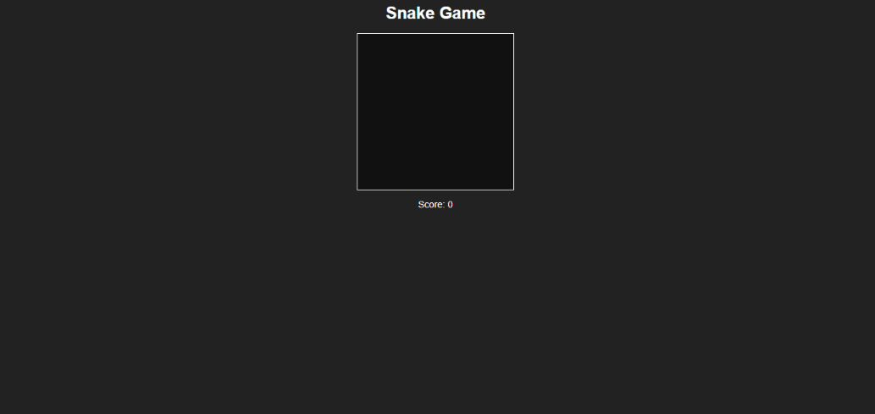

**3. GAME CLIKE THE CLIKE**

* INDEX.HTML

<!DOCTYPE html>

<html lang="en">

<head>

  <meta charset="UTF-8" />

  <meta name="viewport" content="width=device-width, initial-scale=1.0"/>

  <title>Click the Circle</title>

  <link rel="stylesheet" href="style.css"/>

</head>

<body>

  <h1>Click the Circle!</h1>

  <div id="circle-game">

    <div id="circle"></div>

  </div>

  <p>Time Left: <span id="time">30</span>s | Score: <span id="score">0</span></p>

  <script src="app.js"></script>

</body>

</html>

* APP.JS

const circle = document.getElementById('circle');

const scoreDisplay = document.getElementById('score');

const timeDisplay = document.getElementById('time');

let score = 0;

let timeLeft = 30;

function moveCircle() {

  const x = Math.random() * 260;

  const y = Math.random() * 260;

  circle.style.left = ${x}px;

  circle.style.top = ${y}px;

}

circle.addEventListener('click', () => {

  if (timeLeft > 0) {

    score++;

    scoreDisplay.textContent = score;

    moveCircle();

  }

});

const timer = setInterval(() => {

  timeLeft--;

  timeDisplay.textContent = timeLeft;

  if (timeLeft <= 0) {

    clearInterval(timer);

    circle.style.display = 'none';

    alert(Game over! Your score is ${score});

  }

}, 1000);

moveCircle();

* **STYLE.CSS**

body {

    font-family: Arial, sans-serif;

    text-align: center;

    background: radial-gradient(circle, #fbc2eb 0%, #a6c1ee 100%);

    margin: 0;

    padding: 0;

  }

  h1 {

    margin-top: 30px;

    color: #333;

  }

  #circle-game {

    position: relative;

    width: 300px;

    height: 300px;

    margin: 30px auto;

    border: 2px solid #fff;

    background-color: #fff;

    overflow: hidden;

    border-radius: 10px;

  }

  #circle {

    width: 40px;

    height: 40px;

    background-color: purple;

    border-radius: 50%;

    position: absolute;

    top: 50px;

    left: 50px;

    cursor: pointer;

    transition: all 0.2s ease;

  }

  p {

    font-size: 18px;

    color: #fff;

  }

GAMBAR :

